EMPOWERING COMMUNITIES THROUGH CLEAN WATER: THE KITURA – KASHONGI PIPED WATER SYSTEM
In Kashongi County, Kiruhura District, a transformative water project is reshaping lives and livelihoods across two rural sub-counties of Kitura and Kashongi. The Kitura–Kashongi Piped Water System, a gravity-fed scheme, is a flagship initiative implemented by the Kiruhura District Local Government in partnership with the South Western Umbrella of Water and Sanitation. With a major investment of UGX 1.1 billion on over 70km of the transmission and distribution mains. This ambitious project was strategically rolled out over three financial years (2022/23, 2023/24, and 2024/25), ensuring long-term sustainability and effective community integration.
The system extends its reach across 8 parishes and a total of 42 villages, bringing a steady and reliable supply of clean water to communities that previously faced chronic shortages. In Kitura Sub- County, the parishes of Bweeza, Rwemamba, Kitura, and Mooya now benefit from the project, while in Kashongi Sub County, villages of Byanamira, Kashongi, Ntarama, Kitabo, and Rwanyangwe have also been covered. This expansive coverage is more than just a technical achievement—it represents a profound shift in the quality of life for thousands of residents.
With 556 household water connections and 15 public tap stands now active, residents no longer need to trek long distances in search of water. As once a Minister of Water and Environment, Hon. Prof. Ephraim Kamuntu said, “Heads are not meant for cutting jerricans of water, they’re simply for discernment purposes”.
The District Water Officer proudly acknowledged that families have now cleaner and safer water at their doorsteps, leading to better hygiene and health. Apparently, connection covers 30 institutions, including health centres, schools, administrative units and places of worship, and this has amplified the project's impact, ensuring that students and community members have access to safe drinking water within their daily environments. As a result, this has fostered better attendance in schools and reduced the time burden on women and children, who traditionally bore the responsibility of fetching water.
Notably, the system has significantly improved healthcare delivery in the region. Kitura Health Centre III and Kashongi Health Centre III, both of which now benefit from a stable piped water supply, are better equipped to maintain hygiene standards and serve patients more effectively. Clean water in health centres reduces the risk of infection, improves maternal care, and enables the management of basic sanitation with greater efficiency—contributing to healthier, more resilient communities.
Kitura–Kashongi Piped Water System is more than infrastructure - it is a foundation for dignity, economic development, and hope. By addressing the fundamental need for clean water, this project has catalyzed a ripple effect of positive change, strengthening public health, enhancing education, and empowering households. It stands as a model of how government collaboration and strategic investment in rural water supply can deliver life-changing results, inspiring similar initiatives across the country.
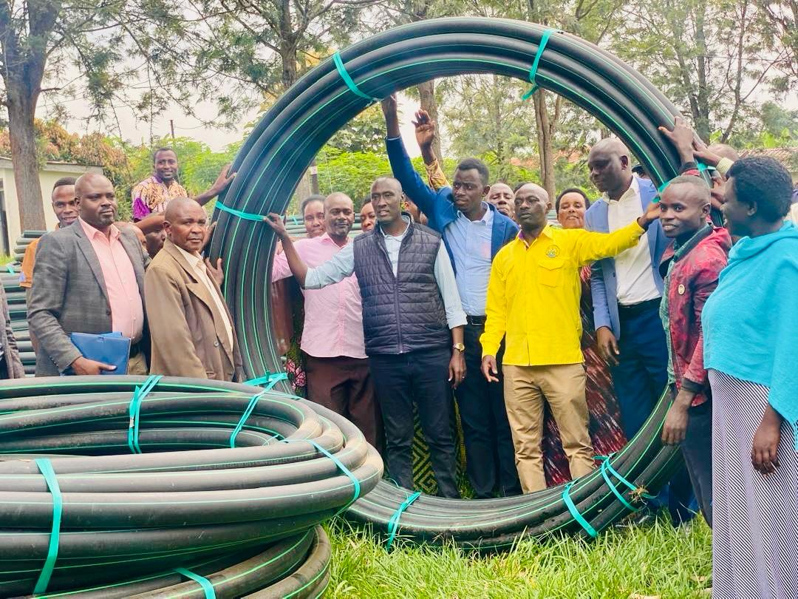 | 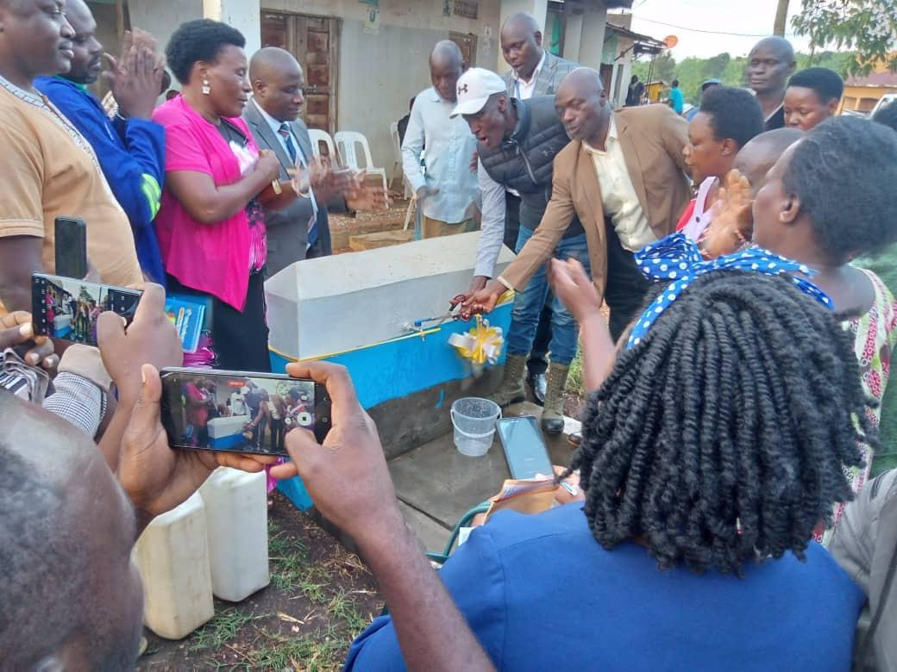
District leaders at the launch of the piped water project in Kashongi S/C (in yellow shirt is the RDC Kiruhura, George Bakunda and next to him District Chairperson, Mukago Dan) | Kiruhura RDC together with the District Chairperson commissioning a piped water supply in Kitura S/C
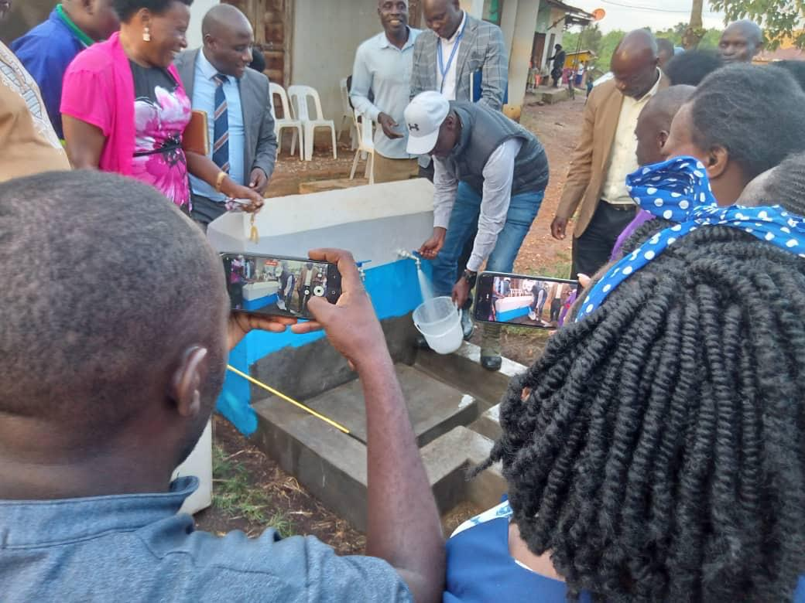 | 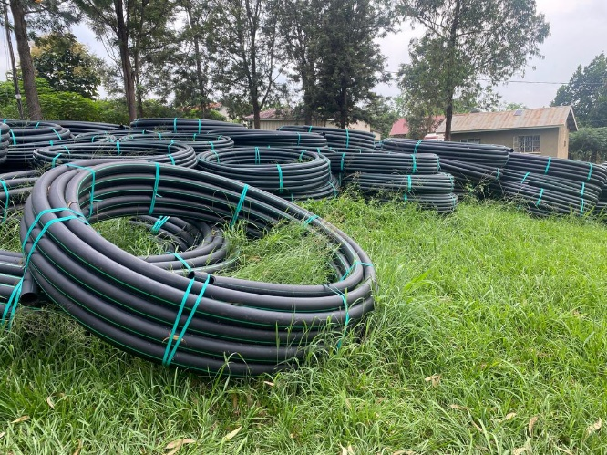
 | Pipes of water delivered at Kashongi S/C HQs
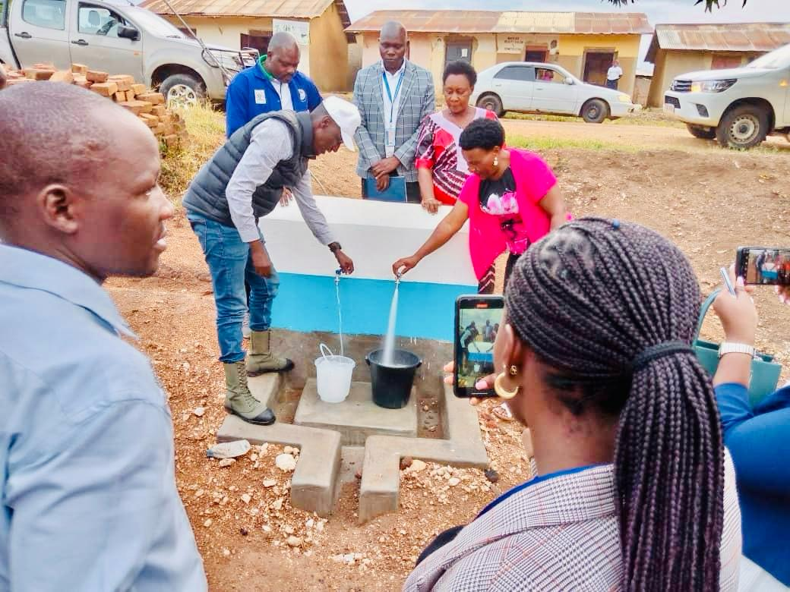 | 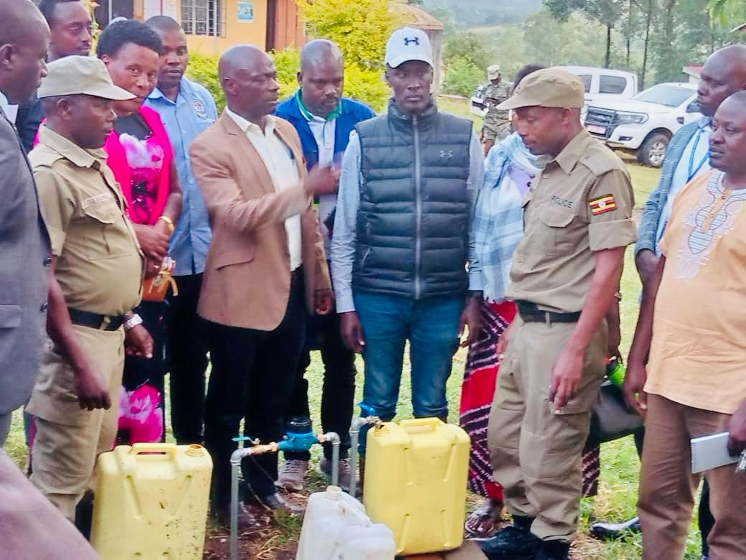
Kiruhura District Chairperson, Mukago Dan together with the Kitura S/C Chairperson Ms Leocadia Byakatonda at the project hand over function in Kitura S/C

END!
The writer is a Senior Communication Officer – Kiruhura District

